**SPRINT 4**

|  |  |
| --- | --- |
| Date | 16 October 2022 |
| Team ID | PNT2022TMID33811 |
| Project Name | Project – Smart Farmer-IoT Enabled smart Farming Application |

**TESTING THE APPLICATION:**

**IBM IOT IS CONNECTED AND DEPLOYED SUCCESSFULLY USING NODE RED:**

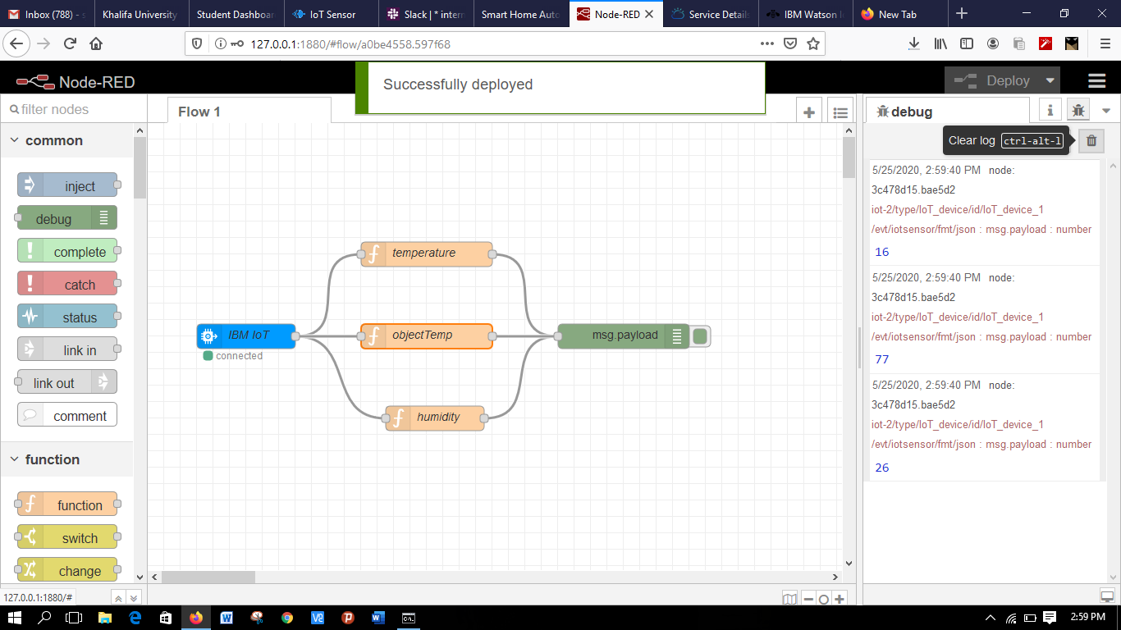

**INPUTS ARE RECORDED BY THE OPEN WEATHER API :**

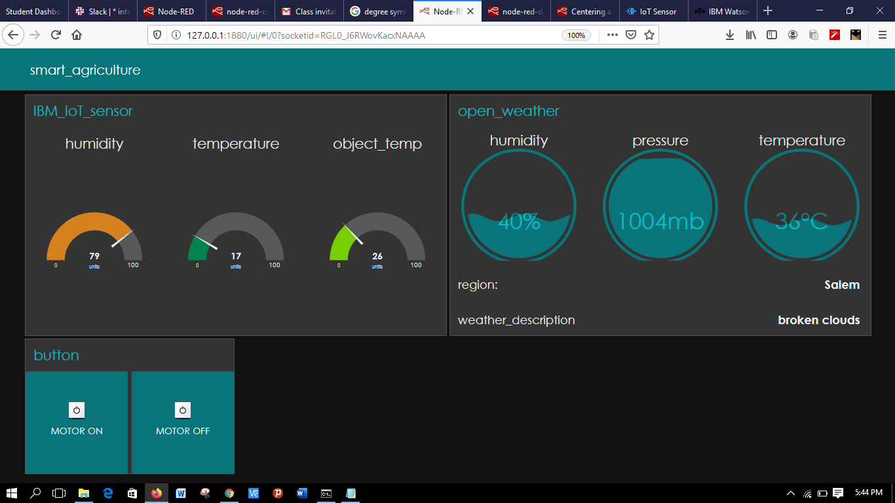

**SMART FARMER APPLICATION:**

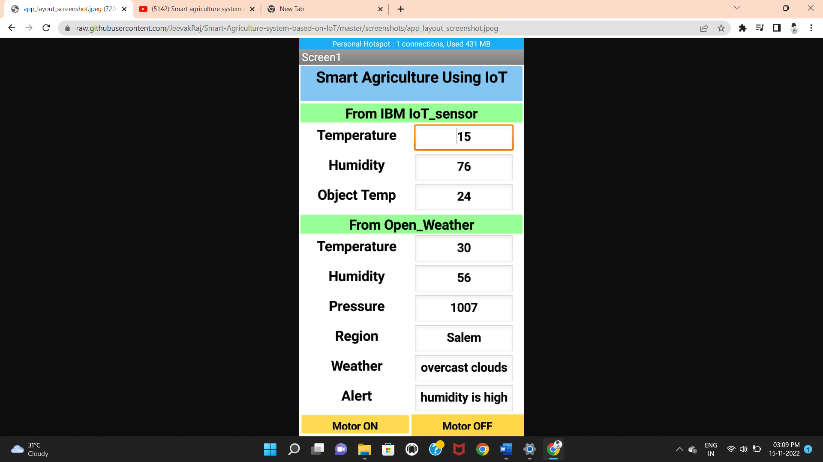

**IOT DEVICE (SIMULATOR) IS CONNECTED AND THE OUTPUT IS DISPLAYED SUCCESSFULLY:**

